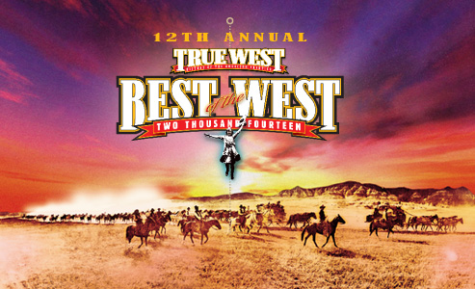
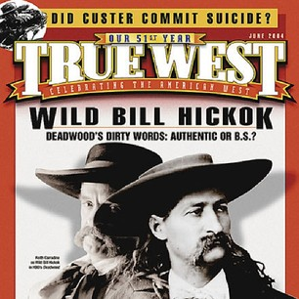

The Best of Western Books for 2014

TRUE WEST magazine’s 12th Annual Celebration of the

Absolute Best of the West!
Here are the winners: "2014 Best of the West." --By J. Stuart Rosebrook--
BEST REAL AND IMAGINED WEST: The Searchers: The Making of an American Legend by Glenn Frankel (Bloomsbury).
BEST OF THE REST:
1. Classic Western Art: Art of the American Frontier: From the Buffalo Bill Center of the West by Stephanie Mayer Heydt, Mindy N. Besaw and Emma I. Hansen (Yale University Press).
2. Modern Western Art: Schenck in the 21st Century by Amy Abrams (Schenck Southwest Publishing).
3. Poetry: A Cowboy Spirit by Stuart Hooker (XLibris).
4. Film/Television: Dream West: Politics and Religion in Cowboy Movies by Douglas Brode (University of Texas Press).
5. Western Craftsmanship: The Colt: The Revolver of the American West by Jeffrey Richardson (Rizzoli).

